**THE COPPERBELT UNIVERSITY ROBOTICS CLUB MECHANICAL DEPARTMENT 3-D PRINTER REPORT ON THE STRUCTURAL COMPONENTS.**

This report gives the specifications of the components to be used in the 3-D printer. These components will facilitate the smooth motion/movement of the nozzle assembly in all the three (X, Y, Z) axes and also offer a firm structural support to the nozzle assembly noting the masses of the components to be used. Below is a brief on the selected components to be used;

1. **Components to aid motion in the axes:** the components to aid the nozzle movement in all the 3-axes includes:
2. Nema-17 stepper motor
3. Tr8 lead screws of not less than half a meter in length (L ≥ 0.6 m)
4. Solid rails/guides of at least not less 8mm in diameter
5. Ball bearings will be used to house the end of the lead screws not coupled to the stepper motor
6. Nuts will also be used to locate/guide the lead screws in the designed knobs

* **Below is summary in picture view of the components.**

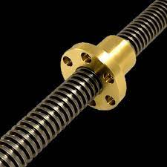

**1.Tr8 Lead screw and Nut**

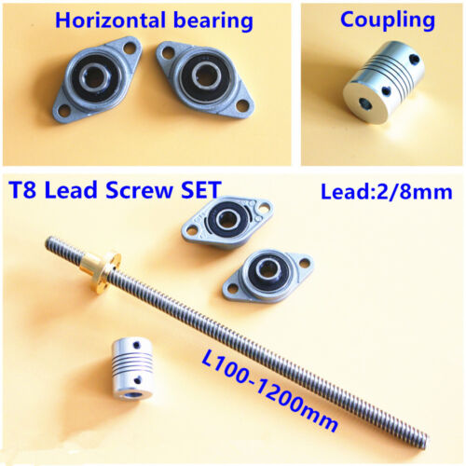 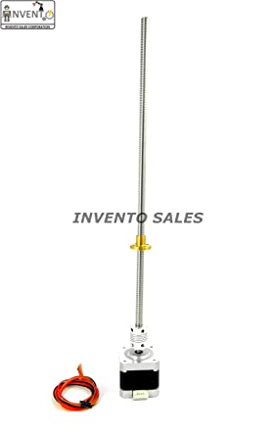

2**. Lead screw and Bearing set**

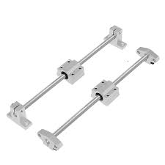

**3. Guides/rods**

1. Nozzle and Fan:

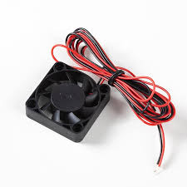 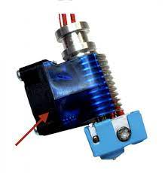

1. Motors:

